**User Story**:

-

A client has requested a self service SPA platform to allow veterinary job seekers and providers a place to connect and form employment arrangements. The platform should aim to be free in its basic form with users (seekers and providers) electing to pay for extras if they wish to be more competitive in gaining employment or seeking employees, respectively. As a added feature, from the data gathered from each party, strong analysis and reporting real time information should be provided to the users as an extra benefit to using the site and encourage re-visits because of it.

The presentation of the site will primarily involve a GUI to search job seekers/profiles, institutions and there listings. The search bar should be very responsive with listing unfolding as the user types, a one space fits all event, and user friendly . Most listing that are clickable should action a pop window to further delve into that item, and that item should disappear when clicked away from with maybe a warning prompt first in cases of sensitive data being lost

Users should view there sign in details in the main screen frame screen and login/logout when desire, of which will change there access to certain action and details of the listings. User accounts should have tabs for there details and employment status/associated institutions/past institutions, listings and control of jobs applied for and listings and control of jobs offered by employees, and a notification pages/pop-up of any changes related to these pages

Anyone can search through the listings but visitors need to register as a user to participate in creating, modifying their own job seeker/profile listing or to create an institution and job adverts. There profile should be updateable as needed and only ever soft deleted or put in non-contactable mode should they wish to return after leaving or finding employment.

Only a user can create an institution, and that institution will then be linked to that users account. If the user who created the account decides later to un-associate the Institution from their user account they will have to delete the institution or elect to nominate a reassigning it to another user and that user will have to accept the invitation to take over. That user will then become the administrator of that institution account and invite or sever other user associations and permission to it as needed. Institution associations of user accounts will be related to current employment of staff

Advertisements or job listings are created by the institution administrator or institution associates with similar permissions granted. Advertisement creation will list a bunch of extra features at the end of the details input form that can be selected to improve the advert listing for a certain cost. These extra features can later be added and paid for after the listing is posted. The advert, once posted should have clickable actions only accessible by other users that involve applying for that position.

Institution administrators or associates with similar permissions granted should also be able to search job seeker listing and make offerings based on their advertisements.

One of the greatest benefits to registration is notifications. Job seekers and employer can set there notification setting to receive alerts when new jobs come up or new people are seeking employment (say in there area or an area they specify). The idea is to make the whole job/employee seeking process streamline.

All pages should have the periodic pop of stats down in the bottom of the screen showing things like “people who just gained employment”, “no.s of people online”, “new jobs advertisements” etc, and this pop up could then like to a reports/statistics page(s) based on current database data.

Additional thoughts, the site could provide template work agreements/offerings. Static pages could include information on boards, registration, …whatever.

**Requirements**:

|  |  |
| --- | --- |
| Functional | |
|  | * The site will will contain job seekers, job providers, and job listings which will be searchable via a search bar. * The listings profiles and listing can be clicked on for more information, then to apply, offer a job or even communicate with another user. * Anyone can search through job seekers, business owners and job listing but an account is needed to apply for or offer a job and communicate between users. * People can sign in and create account profiles for their job seeking profile, company and businesses * Users will have profile pages for their job seeking and job provider profile information supplied. Their personal page will list there resume details etc. and their provider page will list their company details, and business details * Only users who register businesses can post job listings * Users can pay for extra features that allow their listing to be featured whch can occur on or after creation of their job advertisment * Job seekers can apply for jobs advertisements or be offered them by job providers. * Users will have a job-seeking activity page to list job applications and job offers they have made and received. * Users will have a job-provider activity page to list their own posted job advertisements. * When clicked on from the job-provider activity page a job listing will display the offers and applications that have been made towards and from the listing, respectively. * When clicked on, an application or offer listing (from either activity page) users will be able to write and read messages associated with the application or offer. The message GUI is to be decide (new page or assocated GUI feature like a pop-up etc.) * Users can exchange attachments via messages if they choose. * All pages will be customizable via the information supplied and a user profile settings. * The user settings will include a privacy settings which will affect the searchabiliity and display of the users profile listings, user pages, job listings, applications and offers and associated data. Specific privacy setting to be decided later. * Job-seekers, and job-providers should be notified of job listing, application and offer changes. * The job listed advertisment will have a status and be represented via a GUI feature. * The statuses and timings are to be decided but could include “posted”, “**new activity{count}**”, “expired”, “re-listed{count}”, and “removed” * The application and offer listing will have a status and be represented via a GUI feature * The statuses and timings are to be decided but could included “pending”, “rejected”, “in-contact”, “accepted”, “position filled”, “job expired”, “job removed”. * *The interactions between the between job seekers and job provider applications, offers and job listing will form a complex state relationship and will be eluciated via state diagrams later* |
| Non-Functional | |
| Usability |  |
| Reliability | - |
| Performance |  |
| Supportability |  |

**State Diagrams**:

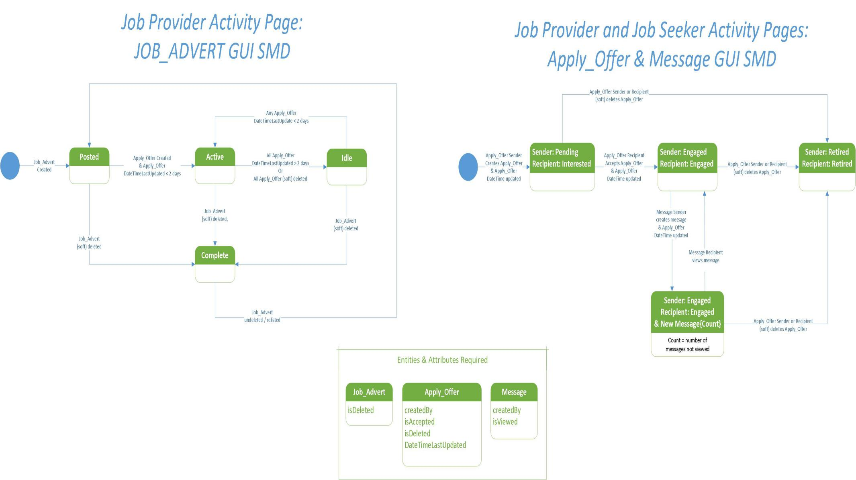

**Use Case-CRUD Analysis**:

|  |  |  |  |  |  |  |  |  |  |  |  |  |  |
| --- | --- | --- | --- | --- | --- | --- | --- | --- | --- | --- | --- | --- | --- |
| **Core Use Case Analysis** | | | | | | | | | | | | | |
| **Use Case**  **/**  **Entity** | **Event**  **Type**  (external, temporal,  state) | USER | USER  _LOG | PRIVACY  _SETTING | BLOCKED  _USER | GENERAL  _INFO  + | COMPANY  _PROFILE  & COMPANY  _PHOTO | BUSINESS  _PROFILE  & BUSINESS  _PHOTO | JOB  _ADVERT | EXTRA  _FEATURE  & ADVERT  _EXTRA | APPLY  _OFFER | MESSAGE | MESSAGE  _ATTACHMENT |
| Register user account | Ext. | C | C | C |  | C | C | C |  |  |  |  |  |
| Edit user account details | Ext. | R, U | C | R, U |  | R, U | R, U | R, U |  |  |  |  |  |
| View job listings | Ext. |  |  |  | R? |  | R | R | R | R |  |  |  |
| View job seekers | Ext. | R |  | R | R? | R |  |  |  |  |  |  |  |
| Create a job advert | Ext. |  | C |  |  |  |  |  | C | C |  |  |  |
| Add extra features to advert after created | Ext. |  | C |  |  |  |  |  |  | C |  |  |  |
| Offer a job advert to a seeker or apply for a job advert as a seeker | Ext. |  | C |  |  |  |  |  |  |  | C |  |  |
| View job offers and applications | Ext. |  |  |  |  |  |  |  |  |  | R |  |  |
| View job listing for certain providers | Ext. |  |  |  |  |  |  | R | R | R |  |  |  |
| Accept a job application or offer | Ext. |  |  |  |  |  |  |  |  |  | U |  |  |
| Message user after accepting job offer or job application. | Ext. |  |  |  |  |  |  |  |  |  | U | C |  |
| View messages |  |  |  |  |  |  |  |  |  |  |  | R, U |  |
| Send and receive employment contract | Ext. |  |  |  |  |  |  |  |  |  |  | C, R | C, R |
| **Delete** a job advertisement | Ext. |  |  |  |  |  |  |  | U | D |  |  |  |
| **Delete** Job Seeker Details | Ext. |  |  |  |  | D |  |  |  |  |  |  |  |
| **Delete** Job Provider  Company Details |  |  |  |  |  |  | D |  |  |  |  |  |  |
| **Delete** Job Provider Business Details |  |  |  |  |  |  |  | U | U | D |  |  |  |
| Block or unblock a user | Ext. |  |  |  | C, D |  |  |  |  |  |  |  |  |
| **Delete** user account | Ext. |  | C | U |  |  |  |  |  |  |  |  |  |

**Conceptual Database Design**:

- Entity Relationship Diagram.

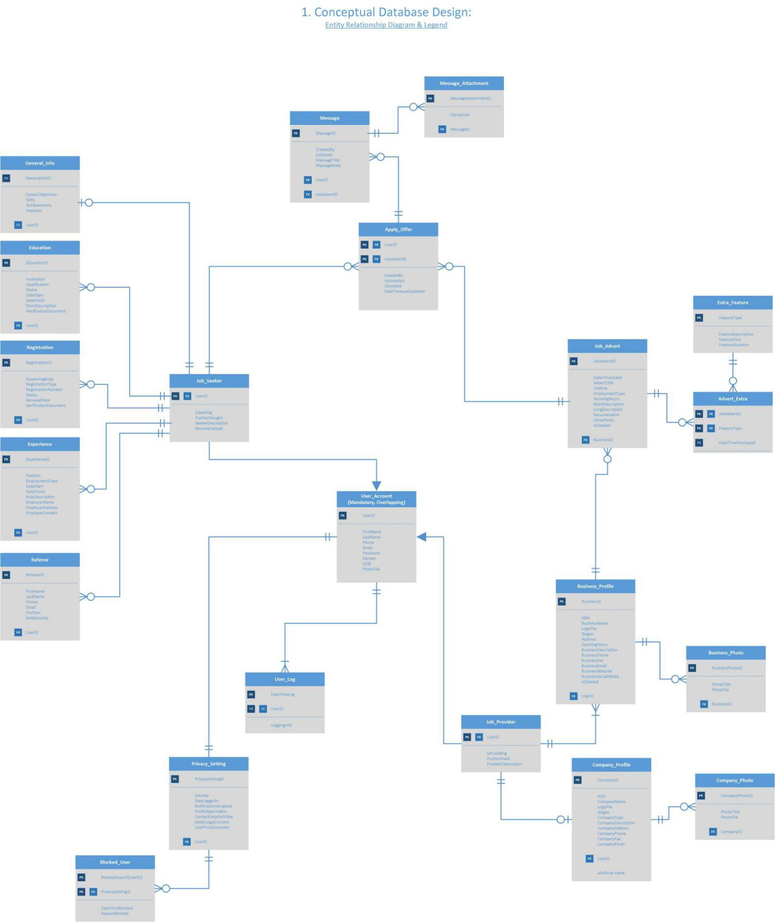

**Logical Database Design**:

- Entity-Relational Schematic

USER (**userID**, firstName, LastName, gender, dOB, phone, email, password, photo, jobSeekerFlag, isSeeking, positionSought, seekerDescription, resumeUpload, jobProviderFlag, isProviding, positionHeld, providerDescription)

PRIVACY_SETTING(**privacySettingID**, isActive, stayLoggedIn, notificationsEnabled, isSearchable, detailsVisible, cookiesConsent, dataUsageConsent, userPhotoConsent, userID)

BLOCKED_USER(**blockedUserID , privacySettingID**, dateTimeBlocked, reasonBlocked)

USER_LOG(**dateTimeLog, userID**, LoggingInfo)

GENERAL_INFO(**generalInfoID**, careerObjectives, skills, achievements, interests, userID)

EDUCATION(**educationID**, institution, qualification, status, dateStart, dateFinish, shortDescription, verificationDocument, userID)

REGISTRATION(**registrationID**, governingBody, registrationType, registrationNumber, status, renewalDate, verificationDocument, userID )

EXPERIENCE(**experienceID**, position, employmentType, dateStart, dateFinish, roleDescription, userID, employerID)

EMPLOYER(**employerID**, employerName, employerAddress, employerContact)

REFEREE(**refereeID**, firstName, lastName, phone, email, position, relationship, userID)

COMPANY_PROFILE(**companyID**, companyName, openingHours, companyDescription, ACN, companyAddress, companyPhone, companyFax, companyEmail, companyLogoFile, companySlogan, companyWebsite,company companySocialMedia, userID)

COMPANY_PHOTO(**companyPhotoID**, photoTitle, photoFile, companyID)

BUSINESS_PROFILE(**businessID**, ABN, businessName, businessLogoFile, businessSlogan, businessType, businessDescription, businessAddress,businessPhone, businessFax, businessEmail, businessWebsite, isDeleted, userID)

BUSINESS_PHOTO(**businessPhotoID**, photoTitle, photoFile, businessID)

JOB_ADVERT(**jobAdvertID**, dateListed, advertTitle, jobRole, employmentType, workingHours, shortDescription, longDescription, renumeration, otherPerks, isDeleted, businessID)

ADVERT_EXTRA(**jobAdvertID, featureType**, **dateTimePurchased**)

EXTRA_FEATURE(**featureType**, featureDescription, featureCost, featureDuration)

APPLY_OFFER(**userID, jobAdvertID**, createdBy, isAccepted, isDeleted, DateTimeCreated)

MESSAGE(**messageID**, createdBy, isViewed, messageTitle, messageBody, userID, jobAdvertID)

MESSAGE_ATTACHMENT(**messageAttachmentID**, fileUpload, messageID)

**Logical Database Design**:

- Normalization (consistent with schematic only)

1. USER could be split however kept all in one table for now due to “supertype-subtype mandatory participation and overlapping ERD to tables” recommendations
2. Could change PRIVACY_SETTING into different types but not sure on the attributes needed for privacy yet, so will hold off for now and maybe continue as a feature to be added after production.
3. EMPLOYER entity split from EXPERIENCE entity and one-to one relationship created with foreign key in child side to keep ensure the relationship is mandatory (EXPERIENCE always references and EMPLOYER)

Extras

- added more address related fields to EMPLOYER, COMPANY_PROFILE, and BUSINESS_PROFILE

- added dateTimeCreated to MESSAGE

**Logical Database Design**:

- Transaction Desk-Checking.

|  |  |
| --- | --- |
| **Use Cases** | **Rough SQL** (pending DBMS) |
| Register user account | INSERT INTO USER (firstName, lastName, gender, DOB….ETC)  VALUES (“scott”, “jenkins”, “male”, 06-06-89……ETC)  INSERT INTO PRIVACY_SETTING (isActive, stayLoggedin, notif….)  VALUES (true, true, true…..)  INSERT INTO ……ETC…. |
| Edit user account details | INSERT INTO GENERAL INFO (skills, interests, userID)  VALUES (“diving”, “leggo”, “authenticated_userID”)  UPDATE GENERAL_INFO  SET careerObjectives = “nurse”, achievements = “sports medal”  WHERE userID = “authenticated_userID” |
| View job listings | SELECT JA.*, BP.businessName  FROM JOB_ADVERT JA, BUSINESS_PROFILE BP  WHERE JA.BusinessID = BP.BusinessID  AND BP.isDeleted = false;  AND …..ETC.  ORDER BY JA. DateListed, BP.businessAddress = “somewhere”….ETC. |
| View job seekers | SELECT *  FROM USER U  WHERE U.jobSeekingFlag = true  AND U.isSeeking = true;  AND U.Address LIKE “tex%”  AND U.resumeUpload IS NOT NULL  AND …..ETC  ORDER BY U.lastName (…or better yet, last active would be nice, NB look in to to user log to calculate this as an order by) |
| Create a job advert | INSERT INTO JOB_ADVERT (advertTitle, jobRole….ETC)  VALUES (“locum vet need”, “senior veterinarian”…..ETC) |
| Add extra features to advert after created | INSERT INTO ADVERT_EXTRA  VALUES (“Ad301”, “featured-two-weeks”, “05-05-2019”)  //EXTRA_FEATURE entities will be hard-coded |
| Offer a job advert to a seeker or apply for a job advert as a seeker | INSERT INTO APPLY_OFFER (userID, jobAdvertID, createdBy….ETC)  VALUES (“authenticated_uderID OR selected_userID”, “Ad301”, “userID”……ETC) |
| View job applications and offers  (for logged in job *seekers* & job *providers*) | //FOR JOB SEEKERS  //applications  SELECT AO.*  FROM APPLY_OFFER AO  WHERE AO.userID = “*authenticated*-*userID*”  AND AO.createdBy = “*authenticated*-*userID*”  //offers  SELECT AO.*  FROM APPLY_OFFER AO  WHERE AO.userID = “*authenticated*-*userID*”  AND AO.createdBy != “*authenticated*-*userID*”  //FOR JOB PROVIDERS  //offers  SELECT AO.*  FROM APPLY_OFFER AO, JOB_ADVERT JA, BUSINESS_PROFILE BP,  WHERE AO.jobAdvertID = JA.jobAdvertID  AND JA.businessID = BP.businessID  AND BP.userID = “*authenticated*-*userID*”  AND AO.createdBy = “*authenticated*-*userID*”  //applications  SELECT AO.*  FROM APPLY_OFFER AO, JOB_ADVERT JA, BUSINESS_PROFILE BP,  WHERE AO.jobAdvertID = JA.jobAdvertID  AND JA.businessID = BP.businessID  AND BP.userID = “*authenticated*-*userID*”  AND AO.createdBy != “*authenticated*-*userID*” |
| View job listing (for logged in users) | SELECT JA.*, BP.businessName  FROM JOB_ADVERT JA, BUSINESS_PROFILE BA  WHERE JA.businessID = BP.businessID  AND BP.userID =“*authenticated*-*userID*” |
| Accept a job application or offer  //pretty tricky if trying to use a universal query for the seeker and provider, as have to update APPLY_OFFER based on the userID values found in the BUISNESS_PROFILE and APPLY_OFFER entities. However could just restrict this with the applications and offers displayed in the GUI however this would probably be considered “security via obscurity” so will need to think about this further if this query doesn’t work… | UPDATE APPLY_OFFER  SET AO.isAccepted=true;  FROM APPLY_OFFER AO, JOB_ADVERT JA, BUISNESS_PROFILE BP  WHERE AO.jobAdvertID = JA.jobAdvertID  AND JA.businessID = BP.businessID  AND NOT AO.createdBy = “authenticated_userID”  AND  (AO.userID = “authenticated_userID”  OR  BP.userID = “authenticated_userID”) |
| Message user after accepting job offer or job application. | INSERT INTO MESSAGE  VALUE (“authenticated_userID”, false “some title here”….ETC) |
| View messages & attachments  (for a particular offer or application)  *assumes user can only access messages for the listed applications and offers they are restricted to click on in their job seeker and job provider activity pages. | //FOR JOB SEEKER & PROVIDERS    SELECT M.messageTitle, M.messageBody, MA.fileUploaded  FROM MESSAGE M, APPLY-OFFER AO, MESSAGE_ATTACHMENT MA  WHERE {M.userID, M.jobAdvertID} = {AO.userID, AO.jobAdvertID}  AND M.messageID = MA.messageID; |
| Send and receive an employment contract  (attach a file to a message) | INSERT INTO MESSAGE_ATTACHMENT (fileUpload, messageID)  VALUES (file.txt, 22000); |
| **Delete** a Job advertisement | UPDATE JOB_ADVERT  SET isDeleted  FROM JOB_ADVERT, BUSINESS_PROFILE  WHERE JOB_ADVERT.jobAdvertID = “selected_jobAdvert”  AND BP.userID = “authenticated_userID”; |
| **Delete** Job Seeker Details |  |
| **Delete** Job Provider  Company Details |  |
| **Delete** Job Provider Business Details |  |
| Block or unblock a user |  |
| **Delete** user account |  |

**Physical Database Design**:

- Data Dictionaries

Note:

* P/F Key = primary / foreign key,
* Desc. = description of property,
* Def. = default value,
* O/R = optional (nullable) or required,
* Uniq. = unique value,
* Gen. = generated property value,
* Seq. = sequence,
* Comp. = computed property value,
* Ind. = indexed property,
* Conc. = concurrency token property,
* On Update/Delete Behaviour: Cascade - Set Null - Restrict

|  |  |  |  |  |  |  |  |  |  |  |  |  |
| --- | --- | --- | --- | --- | --- | --- | --- | --- | --- | --- | --- | --- |
| **APPLY_OFFER** | | | | | | | | | | | | |
| P/F  Key | Column  Name | Desc. | Data Type & Size  (C# & MSSQL) | Domain Constraints | Def. | O/R | Uniq. | Comp. | Gen. & Seq. | Ind. | Conc. | Referential Integrity Constraints |
| PK  FK | userID |  | int |  |  | R |  |  |  |  |  | On delete restrict |
| PK  FK | jobAdvertID |  | int |  |  | R |  |  |  |  |  |
|  | createdBy | (userID) | int | Existing userID |  | R |  |  |  |  |  |
|  | isAccepted |  | boolean |  | F | R |  |  |  |  |  |
|  | isDeleted |  | boolean |  | F | R |  |  |  |  |  |
|  | DateTimeCreated |  | DateTime |  | DateTime.Now | R |  | When created |  |  |  |

|  |  |  |  |  |  |  |  |  |  |  |  |  |
| --- | --- | --- | --- | --- | --- | --- | --- | --- | --- | --- | --- | --- |
| **MESSAGE** | | | | | | | | | | | | |
| P/F  Key | Column  Name | Desc. | Data Type & Size  (C# & MSSQL) | Domain Constraints | Def. | O/R | Uniq. | Comp. | Gen. & Seq. | Ind. | Conc. | Referential Integrity Constraints |
| PK | messageID |  | int |  |  | R |  |  |  |  |  | On delete restrict |
|  | createdBy |  | int | Existing userID |  | R |  |  |  |  |  |
|  | dateTimeCreated |  | DateTime |  | DateTime.Now |  |  |  |  |  |  |
|  | isViewed |  | boolean |  | F | R |  |  |  |  |  |
|  | messageTitle |  | string |  |  | O |  |  |  |  |  |
|  | messageBody |  | string |  |  | R |  |  |  |  |  |
| FK | userID |  | int |  |  | R |  |  |  |  |  |
| FK | jobAdvertID |  | int |  |  | R |  |  |  |  |  |

|  |  |  |  |  |  |  |  |  |  |  |  |  |
| --- | --- | --- | --- | --- | --- | --- | --- | --- | --- | --- | --- | --- |
| **MESSAGE_ATTACHMENT** | | | | | | | | | | | | |
| P/F  Key | Column  Name | Desc. | Data Type & Size  (C# & MSSQL) | Domain Constraints | Def. | O/R | Uniq. | Comp. | Gen. & Seq. | Ind. | Conc. | Referential Integrity Constraints |
| PK | messageAttachID |  | uint |  |  | R |  |  |  |  |  | On delete restrict |
|  | fileUpload | filepath | string |  |  | R |  |  |  |  |  |
| FK | messageID |  | uint |  |  | R |  |  |  |  |  |

|  |  |  |  |  |  |  |  |  |  |  |  |  |
| --- | --- | --- | --- | --- | --- | --- | --- | --- | --- | --- | --- | --- |
| **JOB_ADVERT** | | | | | | | | | | | | |
| P/F  Key | Column  Name | Desc. | Data Type & Size  (C# & MSSQL) | Domain Constraints | Def. | O/R | Uniq. | Comp. | Gen. & Seq. | Ind. | Conc. | Referential Integrity Constraints |
| PK | jobAdvertID |  | uint |  |  | R |  |  |  |  |  | On delete restrict |
|  | dateTimeCreated |  | DateTime |  | DateTime.Now | R |  |  |  |  |  |
|  | advertTitle |  | string |  |  | R |  |  |  |  |  |
|  | jobRole |  | string |  |  | R |  |  |  |  |  |
|  | employType |  | string |  |  | R |  |  |  |  |  |
|  | workHours |  | string |  |  | O |  |  |  |  |  |
|  | shortDesc. |  | string |  |  | O |  |  |  |  |  |
|  | longDesc. |  | string |  |  | O |  |  |  |  |  |
|  | renumeration |  | string |  |  | O |  |  |  |  |  |
|  | otherPerks |  | string |  |  | O |  |  |  |  |  |
|  | isDeleted |  | boolean |  | false | R |  |  |  |  |  |
| FK | businessID |  | uint |  |  | R |  |  |  |  |  |

|  |  |  |  |  |  |  |  |  |  |  |  |  |
| --- | --- | --- | --- | --- | --- | --- | --- | --- | --- | --- | --- | --- |
| **ADVERT_EXTRA** | | | | | | | | | | | | |
| P/F  Key | Column  Name | Desc. | Data Type & Size  (C# & MSSQL) | Domain Constraints | Def. | O/R | Uniq. | Comp. | Gen. & Seq. | Ind. | Conc. | Referential Integrity Constraints |
| PK  FK | jobAdvertID |  | uint |  |  | R |  |  |  |  |  | On delete restrict |
| PK  FK | featureType |  | string |  |  | R |  |  |  |  |  |
| PK | dateTimePurchase |  | DateTime |  | DateTime.Now | R |  |  |  |  |  |

|  |  |  |  |  |  |  |  |  |  |  |  |  |
| --- | --- | --- | --- | --- | --- | --- | --- | --- | --- | --- | --- | --- |
| **EXTRA_FEATURE** | | | | | | | | | | | | |
| P/F  Key | Column  Name | Desc. | Data Type & Size  (C# & MSSQL) | Domain Constraints | Def. | O/R | Uniq. | Comp. | Gen. & Seq. | Ind. | Conc. | Referential Integrity Constraints |
| PK | featType |  | string |  |  | R |  |  |  |  |  | On delete restrict |
|  | featDesc |  | string |  |  | R |  |  |  |  |  |
|  | featCost |  | decimal | Valid money |  | R |  |  |  |  |  |
|  | featDuration | No of days | uint |  |  | R |  |  |  |  |  |

|  |  |  |  |  |  |  |  |  |  |  |  |  |
| --- | --- | --- | --- | --- | --- | --- | --- | --- | --- | --- | --- | --- |
| **BUSINESS_PROFILE** | | | | | | | | | | | | |
| P/F  Key | Column  Name | Desc. | Data Type & Size  (C# & MSSQL) | Domain Constraints | Def. | O/R | Uniq. | Comp. | Gen. & Seq. | Ind. | Conc. | Referential Integrity Constraints |
| PK | businessID |  | uint |  |  | R |  |  |  |  |  | On delete restrict |
|  | ABN |  | ulong |  |  | O |  |  |  |  |  |
|  | busName |  | string |  |  | R |  |  |  |  |  |
|  | busLogoFile |  | string |  |  | O |  |  |  |  |  |
|  | busSlogan |  | string |  |  | O |  |  |  |  |  |
|  | busType |  | string |  |  | R |  |  |  |  |  |
|  | busDesc. |  | string |  |  | O |  |  |  |  |  |
|  | busAddress | Street address | string |  |  | O |  |  |  |  |  |
|  | busSuburb |  | string |  |  | O |  |  |  |  |  |
|  | busCity |  | string |  |  | O |  |  |  |  |  |
|  | busCity |  | string |  |  | O |  |  |  |  |  |
|  | busState |  | string |  |  | O |  |  |  |  |  |
|  | busPostCode |  | string | Max 20 |  | O |  |  |  |  |  |
|  | busCountry |  | string |  |  | O |  |  |  |  |  |
|  | busPhone |  | ulong |  |  | O |  |  |  |  |  |
|  | busFax |  | ulong |  |  | O |  |  |  |  |  |
|  | busEmail |  | string |  |  | O |  |  |  |  |  |
|  | busWebsite |  | string |  |  | O |  |  |  |  |  |
|  | isDeleted |  | boolean |  | F | R |  |  |  |  |  |
| FK | userID |  | uint |  |  | R |  |  |  |  |  |

|  |  |  |  |  |  |  |  |  |  |  |  |  |
| --- | --- | --- | --- | --- | --- | --- | --- | --- | --- | --- | --- | --- |
| **BUSINESS_PHOTO** | | | | | | | | | | | | |
| P/F  Key | Column  Name | Desc. | Data Type & Size  (C# & MSSQL) | Domain Constraints | Def. | O/R | Uniq. | Comp. | Gen. & Seq. | Ind. | Conc. | Referential Integrity Constraints |
| PK | businessPhotoID |  | uint |  |  | R |  |  |  |  |  | On delete restrict |
|  | photoTitle |  | string |  |  | O |  |  |  |  |  |
|  | photoFile |  | string | filepath |  | R |  |  |  |  |  |
| FK | businessID |  | uint |  |  | R |  |  |  |  |  |

|  |  |  |  |  |  |  |  |  |  |  |  |  |
| --- | --- | --- | --- | --- | --- | --- | --- | --- | --- | --- | --- | --- |
| **COMPANY_PROFILE** | | | | | | | | | | | | |
| P/F  Key | Column  Name | Desc | Data Type & Size  (C# & MSSQL) | Domain Constraints | Def | O/R | Uniq | Comp | Gen.& Seq | Ind | Conc | Referential Integrity Constraints |
| PK | compID |  | uint |  |  | R |  |  |  |  |  | On delete restrict |
|  | compName |  | string |  |  | R |  |  |  |  |  |
|  | compOpenHours |  | string |  |  | O |  |  |  |  |  |
|  | compDesc. |  | string |  |  | O |  |  |  |  |  |
|  | ACN |  | ulong |  |  | O |  |  |  |  |  |
|  | compAddress | Street address | string |  |  | O |  |  |  |  |  |
|  | compSuburb |  | string |  |  | O |  |  |  |  |  |
|  | compCity |  | string |  |  | O |  |  |  |  |  |
|  | compCity |  | string |  |  | O |  |  |  |  |  |
|  | compState |  | string |  |  | O |  |  |  |  |  |
|  | compPostCode |  | string |  |  | O |  |  |  |  |  |
|  | compCountry |  | string |  |  | O |  |  |  |  |  |
|  | compPhone |  | ulong | Valid phone number |  | O |  |  |  |  |  |
|  | compFax |  | uong | Valid fax |  | O |  |  |  |  |  |
|  | compEmail |  | string | Valid email |  | O |  |  |  |  |  |
|  | compLogoFile |  | string | filepath |  | O |  |  |  |  |  |
|  | compSlogan |  | string |  |  | O |  |  |  |  |  |
|  | compWebsite |  | string | Valid website |  | O |  |  |  |  |  |
|  | compSocialMedia |  | string | Valid website |  | O |  |  |  |  |  |
| FK | userID |  | uint |  |  | R |  |  |  |  |  |

|  |  |  |  |  |  |  |  |  |  |  |  |  |
| --- | --- | --- | --- | --- | --- | --- | --- | --- | --- | --- | --- | --- |
| **COMPANY_PHOTO** | | | | | | | | | | | | |
| P/F  Key | Column  Name | Desc. | Data Type & Size  (C# & MSSQL) | Domain Constraints | Def. | O/R | Uniq. | Comp. | Gen. & Seq. | Ind. | Conc. | Referential Integrity Constraints |
| PK | companyPhotoID |  | uint |  |  | R |  |  |  |  |  | On delete restrict |
|  | photoTitle |  | string |  |  | O |  |  |  |  |  |
|  | photoFile |  | string | filepath |  | R |  |  |  |  |  |
| FK | companyID |  | uint |  |  | R |  |  |  |  |  |

|  |  |  |  |  |  |  |  |  |  |  |  |  |
| --- | --- | --- | --- | --- | --- | --- | --- | --- | --- | --- | --- | --- |
| **GENERAL_INFO** | | | | | | | | | | | | |
| P/F  Key | Column  Name | Desc. | Data Type & Size  (C# & MSSQL) | Domain Constraints | Def. | O/R | Uniq. | Comp. | Gen. & Seq. | Ind. | Conc. | Referential Integrity Constraints |
| PK | generalInfoID |  | uint |  |  | R |  |  |  |  |  | On delete restrict |
|  | careerObj |  | string |  |  | O |  |  |  |  |  |
|  | skills |  | string |  |  | O |  |  |  |  |  |
|  | achievements |  | string |  |  | O |  |  |  |  |  |
|  | interests |  | string |  |  | O |  |  |  |  |  |
| FK | userID |  | uint |  |  | R |  |  |  |  |  |

|  |  |  |  |  |  |  |  |  |  |  |  |  |
| --- | --- | --- | --- | --- | --- | --- | --- | --- | --- | --- | --- | --- |
| **EDUCATION** | | | | | | | | | | | | |
| P/F  Key | Column  Name | Desc. | Data Type & Size  (C# & MSSQL) | Domain Constraints | Def. | O/R | Uniq. | Comp. | Gen. & Seq. | Ind. | Conc. | Referential Integrity Constraints |
| PK | educationID |  | uint |  |  | R |  |  |  |  |  | On delete restrict |
|  | eduIinstitution |  | string |  |  | R |  |  |  |  |  |
|  | eduQualification |  | string |  |  | R |  |  |  |  |  |
|  | eduStatus |  | string |  |  | R |  |  |  |  |  |
|  | eduDateStart |  | DateTime |  |  | O |  |  |  |  |  |
|  | eduDateFinish |  | DateTime |  |  | O |  |  |  |  |  |
|  | eduShortDesc. |  | string |  |  | O |  |  |  |  |  |
|  | eduVerifDoc. |  | string | filepath |  | O |  |  |  |  |  |
| FK | userID |  | uint |  |  | R |  |  |  |  |  |

|  |  |  |  |  |  |  |  |  |  |  |  |  |
| --- | --- | --- | --- | --- | --- | --- | --- | --- | --- | --- | --- | --- |
| **REGISTRATION** | | | | | | | | | | | | |
| P/F  Key | Column  Name | Desc. | Data Type & Size  (C# & MSSQL) | Domain Constraints | Def. | O/R | Uniq. | Comp. | Gen. & Seq. | Ind. | Conc. | Referential Integrity Constraints |
| PK | registrationID |  | uint |  |  | R |  |  |  |  |  | On delete restrict |
|  | governBody |  | string |  |  | R |  |  |  |  |  |
|  | regType |  | string |  |  | R |  |  |  |  |  |
|  | regNumber |  | ulong |  |  | O |  |  |  |  |  |
|  | regStatus |  | string |  |  | R |  |  |  |  |  |
|  | renewalDate |  | DateTime |  |  | O |  |  |  |  |  |
|  | regverifDoc. |  | string | filepath |  | O |  |  |  |  |  |
| FK | userID |  | uint |  |  | R |  |  |  |  |  |

|  |  |  |  |  |  |  |  |  |  |  |  |  |
| --- | --- | --- | --- | --- | --- | --- | --- | --- | --- | --- | --- | --- |
| **EXPERIENCE** | | | | | | | | | | | | |
| P/F  Key | Column  Name | Desc. | Data Type & Size  (C# & MSSQL) | Domain Constraints | Def. | O/R | Uniq. | Comp. | Gen. & Seq. | Ind. | Conc. | Referential Integrity Constraints |
| PK | experienceID |  | uint |  |  | R |  |  |  |  |  | On delete restrict |
|  | position |  | string |  |  | R |  |  |  |  |  |
|  | employType |  | string |  |  | R |  |  |  |  |  |
|  | dateStart |  | DateTime |  |  | R |  |  |  |  |  |
|  | dateFinish |  | DateTime |  |  | R |  |  |  |  |  |
|  | roleDesc. |  | string |  |  | O |  |  |  |  |  |
| FK | userID |  | uint |  |  | R |  |  |  |  |  |
| FK | employerID |  | uint |  |  | O |  |  |  |  |  |

|  |  |  |  |  |  |  |  |  |  |  |  |  |
| --- | --- | --- | --- | --- | --- | --- | --- | --- | --- | --- | --- | --- |
| **EMPLOYER** | | | | | | | | | | | | |
| P/F  Key | Column  Name | Desc. | Data Type & Size  (C# & MSSQL) | Domain Constraints | Def. | O/R | Uniq. | Comp. | Gen. & Seq. | Ind. | Conc. | Referential Integrity Constraints |
| PK | employerID |  | uint |  |  | R |  |  |  |  |  | On delete restrict |
|  | employName |  | string |  |  | R |  |  |  |  |  |
|  | employAddress | Street address | string |  |  | R |  |  |  |  |  |
|  | employSuburb |  | string |  |  | R |  |  |  |  |  |
|  | employCity |  | string |  |  | R |  |  |  |  |  |
|  | employState |  | string |  |  | R |  |  |  |  |  |
|  | employPostCode |  | string | Max 20 |  | R |  |  |  |  |  |
|  | employCountry |  | string |  |  | R |  |  |  |  |  |
|  | employContact |  | ulong |  |  | R |  |  |  |  |  |

|  |  |  |  |  |  |  |  |  |  |  |  |  |
| --- | --- | --- | --- | --- | --- | --- | --- | --- | --- | --- | --- | --- |
| **REFEREE** | | | | | | | | | | | | |
| P/F  Key | Column  Name | Desc. | Data Type & Size  (C# & MSSQL) | Domain Constraints | Def. | O/R | Uniq. | Comp. | Gen. & Seq. | Ind. | Conc. | Referential Integrity Constraints |
| PK | refereeID |  | uint |  |  | R |  |  |  |  |  | On delete restrict |
|  | refFirstName |  | string |  |  | R |  |  |  |  |  |
|  | refLastName |  | string |  |  | R |  |  |  |  |  |
|  | refPhone |  | ulong | Valid phone number |  | O |  |  |  |  |  |
|  | refEmail |  | string | Valid email |  | O |  |  |  |  |  |
|  | refPosition |  | string |  |  | O |  |  |  |  |  |
|  | refRelationship |  | string |  |  | R |  |  |  |  |  |
| FK | userID |  | uint |  |  | R |  |  |  |  |  |

|  |  |  |  |  |  |  |  |  |  |  |  |  |
| --- | --- | --- | --- | --- | --- | --- | --- | --- | --- | --- | --- | --- |
| **USER** | | | | | | | | | | | | |
| P/F  Key | Column  Name | Desc. | Data Type & Size  (C# & MSSQL) | Domain Constraints | Def. | O/R | Uniq. | Comp. | Gen. & Seq. | Ind. | Conc. | Referential Integrity Constraints |
| PK | userID |  | uint |  |  | R |  |  |  |  |  | On delete restrict |
|  | userFirstName |  | string |  |  | R |  |  |  |  |  |
|  | userLastName |  | string |  |  | R |  |  |  |  |  |
|  | userGender |  | string |  |  | O |  |  |  |  |  |
|  | userDOB |  | DateTime |  |  | O |  |  |  |  |  |
|  | userPhone |  | ulong |  |  | O |  |  |  |  |  |
|  | userEmail |  | string | valid email |  | O |  |  |  |  |  |
|  | userPassword |  | string |  |  | R |  |  |  |  |  |
|  | userPhoto |  | string | filepath |  | O |  |  |  |  |  |
|  | jobSeekerFlag |  | boolean |  | F | R |  |  |  |  |  |
|  | isSeeking |  | boolean |  | F | R |  |  |  |  |  |
|  | positionSought |  | string |  |  | O |  |  |  |  |  |
|  | seekerDesc. |  | string |  |  | O |  |  |  |  |  |
|  | resumeUpload |  | string | filepath |  | O |  |  |  |  |  |
|  | jobProviderFlag |  | boolean |  | F | R |  |  |  |  |  |
|  | isProviding |  | boolean |  | F | R |  |  |  |  |  |
|  | positionHeld |  | string |  |  | O |  |  |  |  |  |
|  | providerDesc. |  | string |  |  | O |  |  |  |  |  |

|  |  |  |  |  |  |  |  |  |  |  |  |  |
| --- | --- | --- | --- | --- | --- | --- | --- | --- | --- | --- | --- | --- |
| **PRIVACY_SETTING** | | | | | | | | | | | | |
| P/F  Key | Column  Name | Desc | Data Type & Size  (C# & MSSQL) | Domain Constraints | Def. | O/R | Uniq. | Comp. | Gen. & Seq. | Ind. | Conc. | Referential Integrity Constraints |
| PK | privacySettingID |  | uint |  |  | R |  |  |  |  |  | On delete restrict |
|  | isActive |  | boolean |  | true | R |  |  |  |  |  |
|  | stayLoggedIn |  | boolean |  | true | R |  |  |  |  |  |
|  | notificationEnable |  | boolean |  | true | R |  |  |  |  |  |
|  | isSearchable |  | boolean |  | true | R |  |  |  |  |  |
|  | detailsVisible |  | boolean |  | true | R |  |  |  |  |  |
|  | cookiesConsent |  | boolean |  | true | R |  |  |  |  |  |
|  | dataUsageConsent |  | boolean |  | true | R |  |  |  |  |  |
|  | userPhotoConset |  | boolean |  | true | R |  |  |  |  |  |
| FK | userID |  | uint |  |  | R |  |  |  |  |  |

|  |  |  |  |  |  |  |  |  |  |  |  |  |
| --- | --- | --- | --- | --- | --- | --- | --- | --- | --- | --- | --- | --- |
| **BLOCKED_USER** | | | | | | | | | | | | |
| P/F  Key | Column  Name | Desc. | Data Type & Size  (C# & MSSQL) | Domain Constraints | Def. | O/R | Uniq. | Comp. | Gen. & Seq. | Ind. | Conc. | Referential Integrity Constraints |
| PK | blockedUserID |  | uint | Existing userID |  | R |  |  |  |  |  | On delete restrict |
| PK  FK | privacySettingID |  | uint |  |  | R |  |  |  |  |  |
|  | dateTimeBlocked |  | DateTime |  | DateTime.Now | R |  |  |  |  |  |
|  | reasonBlocked |  | string |  |  | O |  |  |  |  |  |

|  |  |  |  |  |  |  |  |  |  |  |  |  |
| --- | --- | --- | --- | --- | --- | --- | --- | --- | --- | --- | --- | --- |
| **USER_LOG** | | | | | | | | | | | | |
| P/F  Key | Column  Name | Desc. | Data Type & Size  (C# & MSSQL) | Domain Constraints | Def. | O/R | Uniq. | Comp. | Gen. & Seq. | Ind. | Conc. | Referential Integrity Constraints |
| PK | dateTimeLog |  | DateTime |  | DateTime.Now | R |  |  |  |  |  | On delete restrict |
| PK  FK | userID |  | uint | Existing userID |  | R |  |  |  |  |  |
|  | loggingInfo |  | string |  |  | R |  |  |  |  |  |